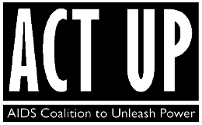
Media: Brandon Cuicchi
Phone: 646.284.2948
Email: media@ACTUPNY.com

FOR IMMEDIATE RELEASE
ACT UP SMEARS TRUMP AND MUSK’S FACES WITH “BLOOD” AT TESLA SHOWROOM

AIDS ACTIVISTS DEMAND CONGRESS REJECT DEADLY CUTS TO GLOBAL AIDS PROGRAM

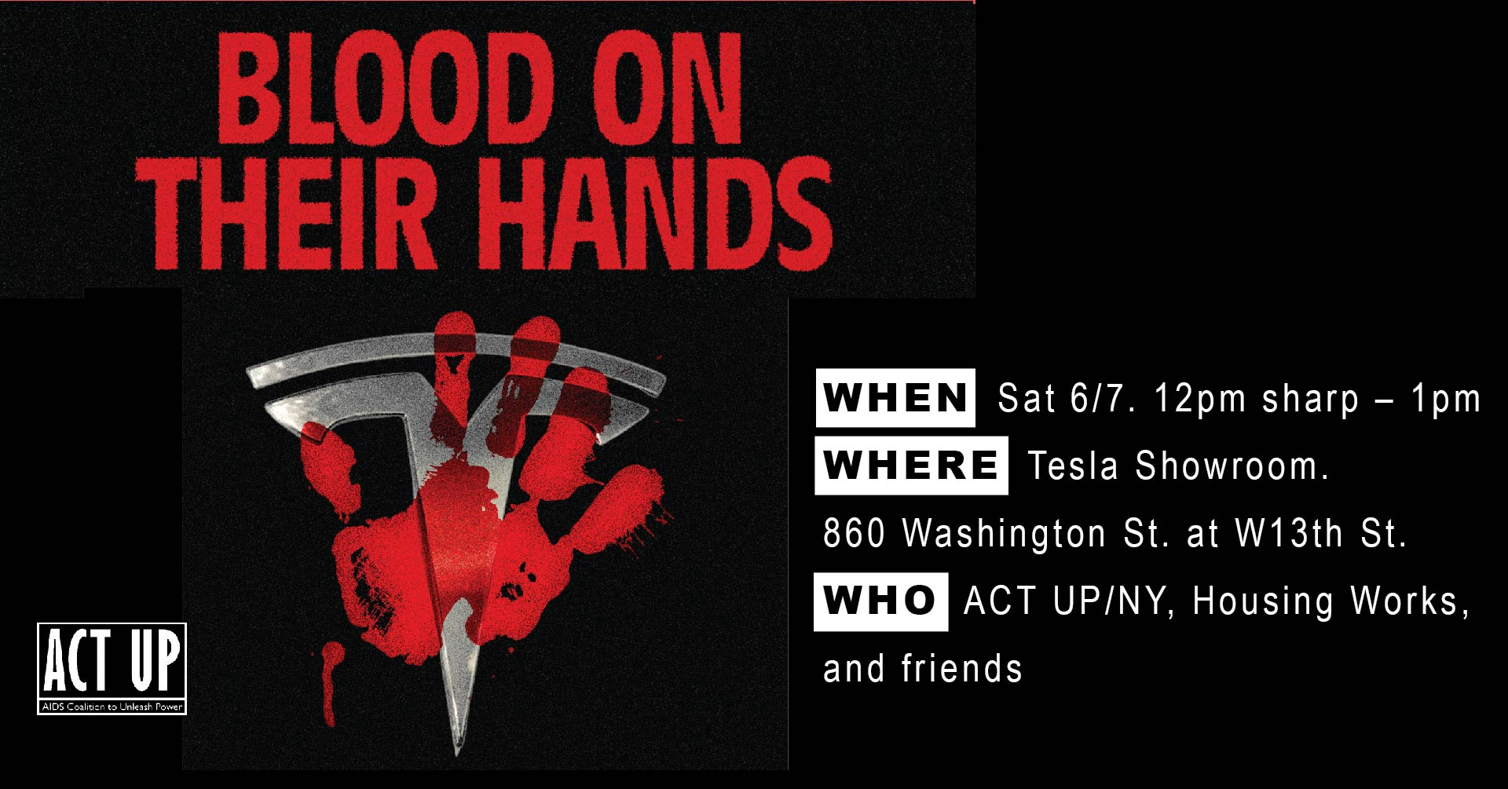

WHAT: Blood On Their Hands
WHEN: Sat 6/7. 12pm sharp – 1pm
WHERE: Tesla Showroom. 860 Washington St. at W13th St.
WHO: ACT UP/NY, Housing Works, and friends
EVENT: https://www.facebook.com/share/1ArD2ho8vX/
New York, NY — June 6, 2025 — On Saturday June 7 at 12pm, ACT UP (AIDS Coalition To Unleash Power) and other AIDS activists will gather outside the Tesla showroom in Manhattan’s West Village to demand Congress reject the proposed rescission package that would lock in catastrophic cuts to the President’s Emergency Plan For AIDS relief or PEPFAR.
The action — dubbed “Blood On Their Hands” — will include speeches, chants, and a “blood painting” ritual, in which activists will dip their hands in red paint and smear images of Donald Trump, Elon Musk, Marco Rubio, and RFK Jr. with them to represent the millions who are projected to die from AIDS if funding cuts to the U.S. global AIDS relief program remain.
Since the January 24th funding freeze of PEPFAR initiated by Elon Musk and his allies and endorsed by the Trump-Rubio bloc, more than 57,000 adults and 6,000 children are estimated to have died globally from HIV-related causes. If the cuts remain, it is believed that 4.8 million people would die from AIDS worldwide by 2028.
“If Donald Trump and Marco Rubio stay on this course laid out by Elon Musk and DOGE, they will be responsible for the deaths of millions of people worldwide,” said ACT UP member Ryan Casey. “Anything they hope to accomplish in the coming years will be overshadowed by mass death on a global scale.”
Established in 2003 under President George W. Bush, PEPFAR has saved over 26 million lives worldwide. Its budget of $4.8 billion annually — less than 12 cents per American per day — provides essential HIV treatment and prevention to some of the world’s most vulnerable populations.
Activists are demanding that Congress fully restore the $4.8 billion annual PEPFAR budget, stop all funding freezes, restore all 2025 and 2024 funding, and reject any 2025 rescission package that undermines global AIDS relief.
At the demonstration, ACT UP will be joined by Housing Works, the New York Metro Chapter of PNHP (Physicians for a National Healthcare Plan), and Rise and Resist.
About ACT UP
Founded in 1987, ACT UP (AIDS Coalition to Unleash Power), is a diverse, non-partisan group of individuals united in anger and committed to direct action to end the AIDS crisis. ACT UP currently meets every Monday night over zoom.

####
